(Approx. 1259)

E-books
By Dick Maybach, Brookdale Computer User Group
www.bcug.com
n2nd (at) att.net

Although still small in comparison to print versions, the market share of e-books is growing, https://en.wikipedia.org/wiki/E-book. In particular, the printed technical manual is disappearing, and when you purchase equipment, the printed material covers little more than its power switch and the URL where you can download detailed information. If open-source software has a manual, it’s available only on-line or as a downloadable e-book. Not surprisingly, the largest commercial e-book vendor is Amazon, and Barnes & Noble also has a substantial stock. Many print magazines are also available in lower-cost electronic form.

There are many good sources of free literature, Project Gutenberg, https://www.gutenberg.org/, has an extensive selection of classic books. The Internet Archive, https://archive.org/index.php, has free books, software, music, and movies. Open Textbook, https://open.umn.edu/opentextbooks/, as its name implies, has textbooks, most contributed by college faculty trying to lower the cost of education. Some organizations publish good e-zines covering topics they support, for example, the MagPi, https://magpi.raspberrypi.org/, covering the Raspberry Pi, and Full Circle Magazine, https://fullcirclemagazine.org/, on Ubuntu Linux. Finally, don’t overlook your local public library.

E-book media can have several formats, https://en.wikipedia.org/wiki/Comparison_of_e-book_formats. The Portable Document Format (PDF) is popular, especially for manuals. It suffers from the disadvantage that line lengths are fixed, making the material awkward to read on small screens and difficult for those with impaired sight. True e-book formats, such as EPUB, are more flexible. Unlike PDF, they aren’t images of printed pages, but just their contents plus embedded formatting commands that the reader software uses to set the displayed font sizes and line breaks. There are many variants; in particular, Amazon, Barnes & Noble, and others have their own proprietary forms. Many readers understand several.

Some readers can convert the format, but this isn’t always possible, and often the results are unsatisfactory. I’ve found that conversion from PDF to EPUB never works well, and it’s always better to put up with PDF’s fixed formatting. Conversion from a document format, such as docx to EPUB often fails, because EPUB is fussy about formatting. For example, if images are anchored as characters, the conversions can be satisfactory, but if they are anchored to pages, it fails. Here too, the safest course is to save the document as PDF and put up with the fixed format.

Digital Rights Management (DRM) limits e-book usability, https://blog.the-ebook-reader.com/2010/10/09/the-ebook-drm-guide/. If you purchase a print book, you can sell it, loan it, or give it away, but this is usually not so for e-books encumbered with DRM. E-books are typically licensed to one person, and perhaps to only one device. The terms vary widely; some allow the use of any device that the purchaser owns, and some allow lending. Some have geographical restrictions. If you cross a border and your reader has GPS, you may find some media unreadable until you return to the United States. But despite the rants circulating on the Internet, DRM is a legitimate feature that was developed to ensure authors and publishers receive payment for their work, but this doesn’t mean it’s convenient for readers.

You can view e-books on your desktop PC, your laptop, a dedicated e-book reader, or a cell phone, and you will probably use more than one. At home, the large screens on desktops and laptops make for comfortable viewing, and of course, the PC is right there for Internet searches and computing. Laptops are usable away from home, but unless power is available, only for relatively short times. You probably always have a cell phone, and using it is always convenient, although its small screen and limited battery life mean it’s really useful only for very short reads. However, you can extend the time with an external battery that powers your phone through its USB port. Often, a short time is all you need. For example, I have my camera’s manual on my phone, which has been helpful to figure out it’s more obscure features when on a trip. If you want to read a book on a long flight, there is really no substitute for a dedicated reader, such as Kindle, especially one with a passive, monochrome display, as the battery life of such devices is multiple days.

There are many e-book software readers available for Linux, OS X, Windows, iOS, and Android. However, I know of no Linux readers for books with DRM, although there are techniques, of at least questionable legality, for removing DRM. If you like new e-books from sellers such as Amazon and want to borrow them from your public library, you will need a commercial reader that supports DRM, such as a Kindle hardware reader or the equivalent software, which means Linux users will be buying hardware. For reading DRM-free books on a PC I prefer Calibre, https://calibre-ebook.com/. With it, you can organize your collection into virtual libraries, edit your books, and change file formats, but with the caveats, I’ve mentioned. Organizing is straightforward. Editing is possible only if the book is in Amazon’s AZW3 format (without DRM) or EPUB (both are a form of HTML), and this requires some expertise to edit.

As with most data sets, it’s important to keep your book collection organized. Calibre assists this with its virtual libraries. Figure 1 shows Calibre’s opening screens with my virtual libraries displayed in a bar just above the book list. They are Calculator, Fiction, PC, Photography, and Technical, and Photography, which has been selected in the figure.

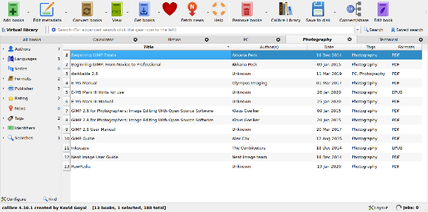
Figure 1. Calibre Opening Screen.

Figure 2 shows an EPUB book open, with its table of contents displayed on the left. You click on the “X” icon at the top right of the panel to close it.

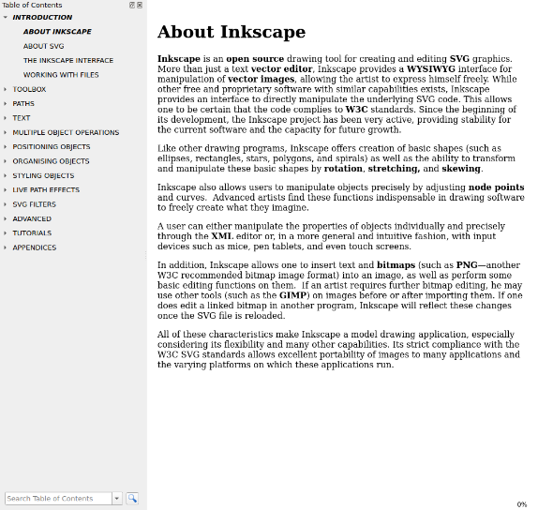
Figure 2. EPUB Book Open for Reading.

You can right-click any time on a page to display the menu shown in Figure 3. This is available only for books in EPUB or similar formats; in particular, it’s not available for PDF books.

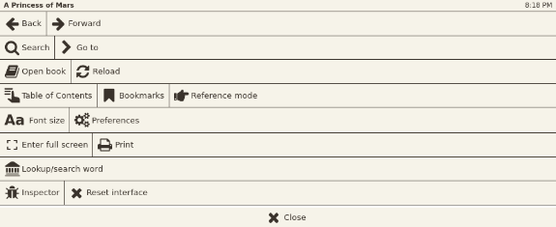
Figure 3. EPUB Book Menu.

One of the advantages of EPUB and similar formats is that you can change the font size to suit your screen size and vision. Figures 4 and 5 show the same passage with different font sizes. Note that the line lengths have adapted, and you don’t have to scroll horizontally.

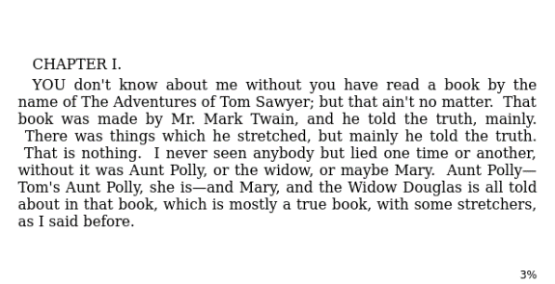
Figure 4. Passage in Normal Font.

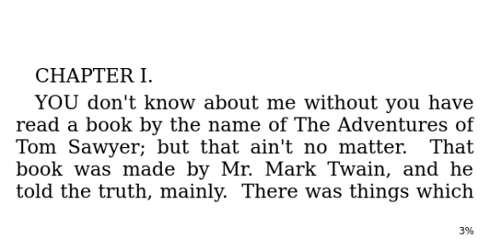
Figure 5. Same Passage in Larger Font.

Calibre uses your default PDF viewer for such files, and this may provide some advantages. For example, Figure 6 shows an e-book with a note I’ve attached (highlighted with yellow). Normally you see only the small icon to the upper left of the note and display the note by selecting the icon. (Selecting the “x” at the note’s upper right hides it.) This feature is not available in Calibre when reading books with EPUB and similar formats.

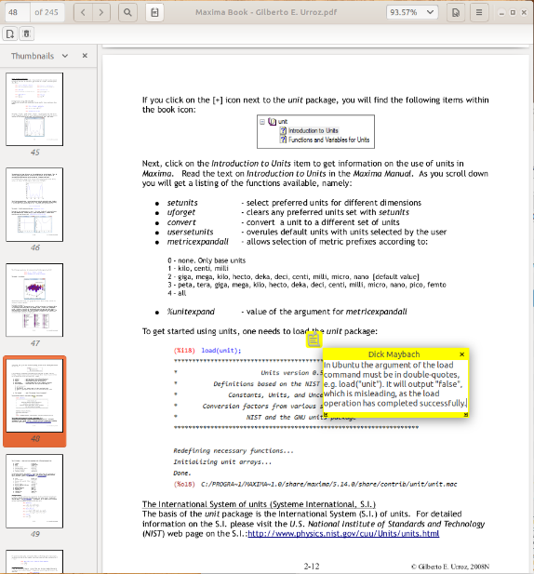
Figure 6. Note Added to a PDF Document.

Also note the page thumbnails displayed in the left panel, which help you navigate through the book. Some PDF books have a table of contents, but you normally have to scroll to their starts to see it. Fortunately, you can make a bookmark to return to your reading.

E-books will continue to proliferate, and to use them efficiently you need a good reader that helps you keep your collection organized. Realistically, no single one will cover all your needs, as your collection will likely be spread over all your devices and into the cloud. As with all your data, take some time to ensure your books are securely backed up, especially if they reside on portable devices.

